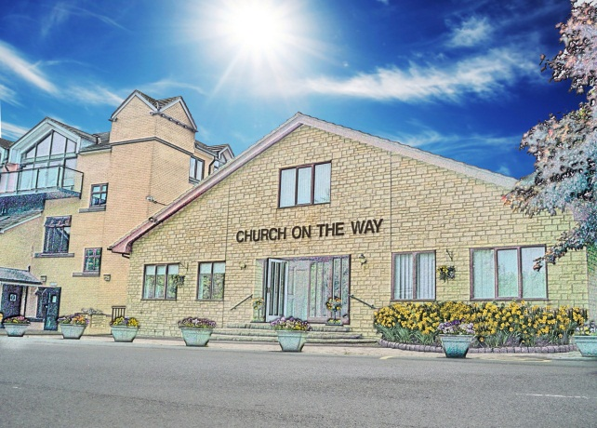

**January 2nd 2020**

Dear Christian Leaders & Friends,

NEW Christian Counselling Courses & Insight Days coming up in 2020

In conjunction with Waverley Abbey College (CWR), Church on the Way is pleased to be hosting further courses that can equip you and others to work effectively both within the church and the wider community.

There will be a ‘Vocational Training in Counselling’ Course - One year part-time throughout 2020 starting on TUESDAYS from FEBRUARY 4th. It will lead to becoming a qualified counsellor. This standard of Christian training has not been available locally before so it is an exciting development for Bradford and further afield.

Also another short course, commencing on May 30th 2020 for FIVE consecutive Saturdays, known as ICCC which is particularly helpful for those developing a pastoral care ministry.

Full details of the Courses, How to Book, all Dates and times are in the ATTACHED two sided leaflet . You are invited to print & circulate these as appropriate.

We invite you to drop us an email with any questions you have relating to these Courses, Course fees etc.to: [info@cotw.org.uk](mailto:info@cotw.org.uk) or to [courses@cwr.org.uk](mailto:courses@cwr.org.uk)

We look forward to hearing from you.

Liz Mole - BA (Hons) Counselling, MA Relational Counselling and Psychotherapy.



***158 Bradford Road, Idle, Bradford BD10 8SA***

***Pastor: David Barlow***

**‘Phone: 01274 617737 Website: www.cotw.org.uk Email Enquiries to: info@cotw.org.uk**

**Church on the Way**

***‘I am the way, the truth, and the life. No one***

***comes to the Father except through Me’. (Jesus) John 14 v 6***